Project Plan

Backbone Slideshow Project

KCCY

Table of Contents
1. Introduction 3
1.1 Foreword 3
1.2 Background 3
2. Project Organization 3
2.1 Development Model 4
2.2 Project Team 5
3. Risk Analysis 5
3.1 Risk Analysis (Table I) 5
3.2 Risk Analysis (Table II) 5
3.3 Risk Analysis Strategy (Table) 5
4. Hardware and Software Requirements 6
5. Schedule and Breakdown Structure 6

1. Introduction

1.1 Foreword
The purpose of this document is to provide information about the Backbone Slideshow project. It will include the project schedules, risks, project team, and the work break down structure. This plan will:
- Create a schedule to build the website with a slideshow created with backbone.js
- We just need to download the necessary files and locate the necessary tutorials.
- We shall follow a tentative schedule and have a finished product by the due date.
- We will also be using any necessary tools to code our Slideshow.

1.2 Background
The IS 217-002 Semester project is to learn how to use backbone.js in order to create a website slideshow. We will be willing to make a slideshow by using the backbone.js to make it more than a plain slideshow.

2. Project Organization

2.1 Development Model

The model we are developing is a basic or creative Slideshow using backbone.js for any website to make or to build. This framework is an example of what we are going to make for our project this semester.

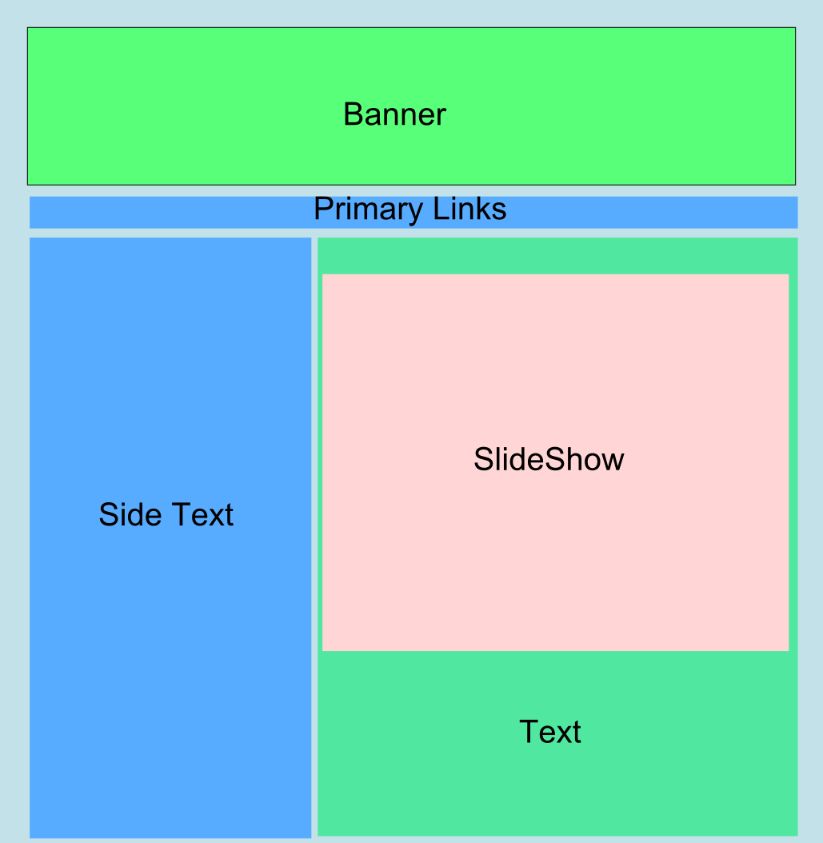

2.2 Project Team
The table below lists the members of the KCCY project team. The project Team consists of Ko Hing Chan (KC) and Charles Yoon (CY)

Project Team
KC (Project Management and Development)
CY (Systems Engineering)
KC, CY (Developer and Internal Tester)
KC (Architecture)
TBA (External Tester)

3. Risk Analysis

3.1 Risk Analysis (Table I)
Risk | Affects | Descriptions
Limited Time (A) | Overall Quality | Limited time with novice exposure to a programming language makes it so much time is allocated to learning the language. A compromise between learning and doing must be established.
Limited Software (B) | Overall Quality | With limited access to software legally, ad hoc methods must be put into play with freeware alternatives.
Limited Availability (C) | Overall Quality | Seeing how both members are commuter students, availability is a big issue, for which communication shall compensate.

3.2 Risk Analysis (Table II)
Risk | Probability | Effects
A | 100% | Varies
B | 100% | Varies
C | 100% | Varies

3.3 Risk Analysis Strategy (Table)
Risk | Solution / Mitigation
A | Time Management and compromise.
B | Freeware
C | Online Communication

4. Hardware and Software Requirements

Browser that is JavaScript enabled. Any operating system with a code editor. But using Google Chrome is the preferred browser to test our project.

5. Schedule and Work Breakdown Structure

